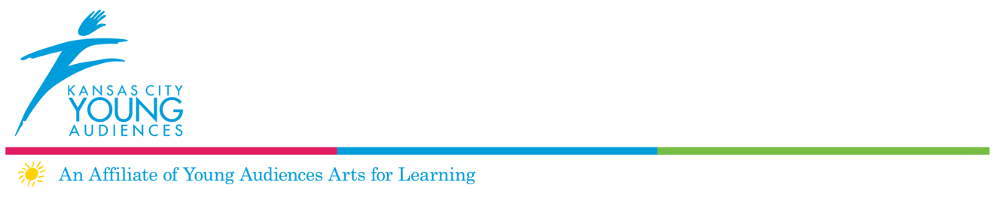

Roster Application 2018

Application Deadline
All applications must be typed and fully completed. Any incomplete or late applications will not be considered for the roster. The deadline for the application is Feb. 23, 2018. The application must be postmarked no later than Feb. 23, 2018

Timeline
Feb. 2, 2018 Preview submission deadline, for applicants wanting feedback prior to final submission

Feb. 23, 2018 Submission deadline for new program applications

March 2018 Panel review of fully completed applications

April 2018 Notification of application status

Tips for Submitting a Strong Application
- Go to http://kcya.lazarusgroup.com/ and look at our current programming. Strong programs have specific curriculum ties.
- Please err on the side of giving us too much information, especially in the instructional plan section of the application.
- Download the sample lesson plan, catalog description, and a copy of the criteria the panel members use to rate your application http://www.kcya.org/full_content.php?article_id=123&full=yes&pbr=1.
- You may submit your application for a preview, if you wish to receive feedback before final submission.
- Be sure to use the checklist and provide the support materials requested. The panel must see you working with children and/or young people. Digital footage (DVD or YouTube only) of you or your ensemble interacting with students is the best way for the panel to view your competency as a teaching artist. If digital footage is unavailable, please contact Kara Armstrong to make alternative arrangements.
- While we give full consideration to all programs submitted, we are looking to create a more culturally diverse roster of artists, and have a particular need for Urban Arts (hip hop dance, rap/spoken word, graffiti), Spanish language programs and visual arts workshops.

Questions
If you have any further questions, please contact:
Kara Armstrong, Director of Arts Education, (816) 531-4022 X1011 or karmstrong@kcya.org

Application must be typed

Contact Information

Artist/Ensemble Name:

Ensemble Leader:

Address:

City:

State:

Zip:

Home phone:

Work phone:

Mobile phone:

Email:

Website URL:

Please postmark application no later than Feb. 23, 2018 to:
Kansas City Young Audiences
Attn: Kara Armstrong, Director of Arts Education
3732 Main Street
Kansas City, Missouri 64111

Application Checklist
Please make sure you have included all of the following items in your packet. Incomplete or applications postmarked after Feb. 23, 2018 will not be accepted.

❑ Contact information (previous page)

❑ Requested lesson plan of performance and/or workshop, see attached
pages

❑ Availability for School year 2017-2018 (be sure to include after-school and evenings)

❑ Catalog description

❑ Updated resume and bio. Please include previous teaching and
residency experience

❑ Examples of professional work, such as photos, audio and/or video

❑ The panel must see you working with children and/or young people. Digital footage (DVD or YouTube only) of you or your ensemble interacting with students is the best way for the panel to view your competency as a teaching artist. If digital footage is unavailable, please contact Kara Armstrong to make alternative arrangements.

❑ Three references with addresses and phone numbers.

❑ Ten (10) copies of your application on plain white paper. Collated, stapled, and three (3) hole punched

❑ Sign and date the application

KCYA Lesson Plan Submission

Please check one:

Workshop

Performance

Performance or workshop title

Appropriate grade levels

Special Requirements (sound system, stage, dressing area, etc.)

Please list specific curriculum connections for your workshop or performance

Instructional Objectives
What do you want your students to learn? What are the skills you want them to develop? Please state your objectives as “students will …”

Vocabulary Words
Please list 7-10 vocabulary words with definitions that relate to your workshop/ performance.

Additional Resources
Please list additional resources (websites, books, articles, etc.) teachers or students may utilize.

Instructional Plan
Please provide a step-by-step description of your performance/workshop. Be specific! Do not spare any details! Please use no more than three typed pages in 12 point font. Remember to include:
  - Hands-on or student-directed activities that take place
  - How you engage students in your art form
  - Key questions you ask during your performance/workshop
  - Any Pre and/ or Post Activities that accompany your workshop/ performance

Assessment
Please list how you assess student’s attainment of your previously listed objectives. How do you determine that your students learned the objectives?

Availability
Be sure to include afterschool and evenings.

Catalog Description
Please type a 3-4 sentence description of your program for our catalog.

________________________________ ________________
Signature of Applicant Date

________________________________
Print Name

